Activate Voice Broadband over Cable

Version Control:

Use Case Name: |  | Activate Voice and Broadband over Cable
Use Case Owner: |  | Sumit Borade
Current Version |  | 0.5
Use Case Version History
Modified Date | Version |  | Modified By | Change Description
June 24, 2009 | 0.1 |  | Tom Schnarr | Initial Version
July 8, 2009 | 0.2 |  | Tom Schnarr | Updated to handle future dated support within Triple
August 26,2009 | 0.3 |  | Sumit Borade | Removed steps not relevant to SMP provisioning
August 28,2009 | 0.4 |  | Sumit Borade | Updated after feedback from YouSee
October 31,2009 | 0.5 |  | Sumit Borade | Added Steps for Static IP Provisioning

Brief Description:
This use case describes the process by which a YouSee subscriber orders voice service over cable at the same time as ordering broadband services.

This use case will extend upon the ‘Activate Broadband Cable’ Use case

Related Documents
- YouSee SMP SOW2Architecture Requirements Document
- YouSee SMP SOW2 Business Requirements Document
- Activate Broadband Cable
- Cisco BACC TC Specification
- Cisco BTS TC Specification

Related Use Cases

Pre-Conditions
- Subscriber resides in a residence served by YouSee cable footprint
- Subscriber is an acceptable credit risk.
- Subscriber has ordered broadband and Voice service – YouSee has a business requirement that a voice over cable subscriber may have previously order broadband services.

Post-Conditions
- Subscriber is free to use Voice over Cable and Broadband service.

Use Case

Primary Flow Diagram
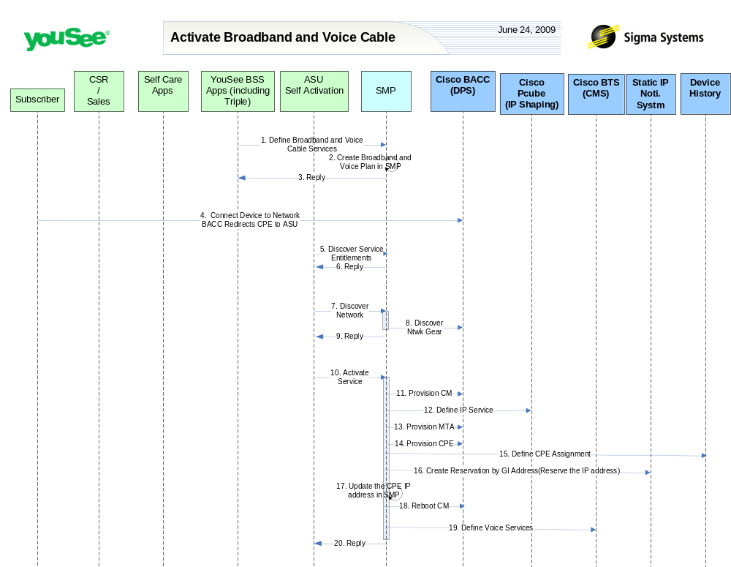

Primary Flow Detail

# | Actor: Key Action | Description | Alternate Flows/Details
 | YouSee BSS: Order is communicated to SMP. Subscriber contacts YouSee and orders Broadband and Voice over Cable service. | YouSee BSS (Triple) will communicate the order to SMP through SMP’s Order Management API. Triple will provide logical services and service attributes. SMP will be required to translate these service/service attributes to engineering level resources and resource attributes. | If the subscriber ordered a ‘leased’ CM, YouSee arranged to ship the device to the customer.  If the subscriber ordered a ‘professional installation’ YouSee schedules a technician for the installation.
 | SMP: Broadband and Voice Cable Service Plan is created in SMP | Broadband and Voice Cable Service plan is created in SMP. SMP will not provision on Network elements since equipment information is not available.
 | SMP: SMP will reply back the status of Order to Triple | SMP will reply back the status of the Order to Triple.
 | Subscriber: Installs CM and PC and launches a browser. Network (BACC) redirects browser to ASU | <As in Activate Broadband Service Use Case> | Alternatively the installation could be preformed by a technician in which case all ‘subscriber’ steps are replaced by ‘technician’
 | ASU: request service entitlements from SMP | <As in Activate Broadband Service Use Case>
 | SMP: SMP sends reply to ASU for Service Entitlement Information | <As in Activate Broadband Service Use Case>
 | ASU: requests SMP to discover network gear | <As in Activate Broadband Service Use Case>
 | SMP: queries BACC and internal inventory to find network gear serving subscriber | <As in Activate Broadband Service Use Case>
 | SMP: Replies back to ASU the information received from CISCO BACC | <As in Activate Broadband Service Use Case>
 | ASU: requests SMP to activate service | <As in Activate Broadband Service Use Case>
 | SMP: defines CM in BACC | <As in Activate Broadband Service Use Case>
 | SMP: defines internet service to CISCO Subscriber Manager | <As in Activate Broadband Service Use Case>
 | SMP: defines MTA on BACC | The MTA is provisioned in BACC with the appropriate services. | AF: if the subscriber has ordered Voice service over this device, the MTA entited is updated in BACC defining that voice service.
 | SMP: defines CPE in BACC | <As in Activate Broadband Service Use Case>
 | SMP: defines device history | <As in Activate Broadband Service Use Case>
 | SMP: Provision Optional static IP Service | <As in Activate Broadband Service Use Case>
 | SMP: Update Static IP Address in SMP System | <As in Activate Broadband Service Use Case>
 | SMP: requests BACC to reboot the CM Device | <As in Activate Broadband Service Use Case>
 | SMP: Provisions voice services in BTS | Sigma defines the voice service in the BTS including defining  - Gateway  - Subscriber/voice line  - Associating subscriber to gateway  - Setting the entities to an activate status  - Assigning the call features
 | SMP: Replies back to ASU the status of Activation | SMP will reply to ASU the status of Provisioning Order to ASU. | If Provisioning fails then SMP will put the Failed task in Manual Queue.

